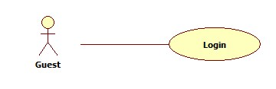

|  |  |  |  |
| --- | --- | --- | --- |
| **USE CASE – GU001** | | | |
| **Use Case No.** | GU001 | **Use Case Version** | 2.0 |
| **Use Case Name** | Login | | |
| **Author** | Tran Le Tuan | | |
| **Date** | 15/01/2014 | **Priority** | Normal |
| **Actor:** Guest.  **Summary:**  Guest use this case to login into system.  **Goal:**  Allow authentication and authorization of the system.  **Triggers:**   * Guest want to login into system. * To login: Guest go to the login page, guest enter username and password, then click on “Log in” button to login.   **Preconditions:** N/A.  **Post Conditions:**   * **Success:** Guest is authorized, redirect to corresponding page. * **Fail:** System will show error on current page   **Main Success Scenario:**   |  |  |  | | --- | --- | --- | | Step | Actor Action | System Response | | 1 | Guest go to login page. | System show a login form, includes:   * Username: textbox (min length: 5, max length: 30, required). * Password: textbox (password box, min length:5, max length: 30, required). * Login: button. | | 1 | Guess enter username and password into textboxs.  Press “Log In” button. | Guest is logged into system, authorized with corresponding role. Redirect to corresponding page..  [Exception 1,2] |   **Alternative Scenario:** N/A  **Exceptions:**   |  |  |  | | --- | --- | --- | | No | Actor Action | System Response | | 1 | No input in “Username” or “Password” textboxs | Show error message: “Please enter username/password” below Username/Password textbox. | | 2 | Username/Password not in range [5,30] | Show error message: “Username/Password must be from 5 to 30 characters” textbox. | | 3 | Input invalid “Username” and “Password” | Show error message: “Invalid username or password”. |   **Relationships:** N/A  **Business Rules:**   * Each user, staff, admin has an account. * Only active account can log in. | | | |

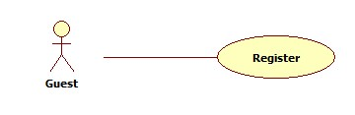

|  |  |  |  |
| --- | --- | --- | --- |
| **USE CASE – GU001** | | | |
| **Use Case No.** | GU002 | **Use Case Version** | 2.0 |
| **Use Case Name** | Register | | |
| **Author** | Tran Le Tuan | | |
| **Date** | 15/01/2014 | **Priority** | Normal |
| **Actor:** Guest.  **Summary:**  Guest use this case to register account into system.  **Goal:**  Allow guest register account into system.  **Triggers:**   * Guest want to register account. * To register: Guest go to the Home page, guest enter username, password, email, address then click on “Register” button to register.   **Preconditions:** N/A.  **Post Conditions:**   * **Success:** System will show sucess on current page * **Fail:** System will show error on current page   **Main Success Scenario:**   |  |  |  | | --- | --- | --- | | Step | Actor Action | System Response | | 1 | Guest go to register page. |  | | 2 | Guess enter username, password, email into textboxs.  Press “Register” button. | System show a register form, includes:   * Username: textbox (min length: 5, max length: 30, required). * Password: textbox (password box, min length:5, max length: 30, required). * Email: textbox ( [abc@xyz.com](mailto:abc@xyz.com) )   Register: button. |   **Alternative Scenario:** N/A  **Exceptions:**   |  |  |  | | --- | --- | --- | | No | Actor Action | System Response | | 1 | No input in “Username” or “Password” or “Email” textboxs | Show error message: “Please enter username/password/email” below Username/Password/Email textbox. | | 2 | Username/Password not in range [5,30] | Show error message: “Username/Password must be from 5 to 30 characters” textbox. | | 3 | Input invalid “Username”. “Password”, “Email” | Show error message: “Invalid username, password or email”. |   **Relationships:** N/A  **Business Rules:**   * Each user can register an account. | | | |

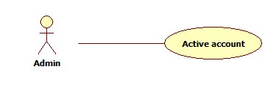

|  |  |  |  |
| --- | --- | --- | --- |
| **USE CASE – AD002** | | | |
| **Use Case No.** | AD002 | **Use Case Version** | 2.0 |
| **Use Case Name** | Active Account | | |
| **Author** | Tran Le Tuan | | |
| **Date** | 15/01/2014 | **Priority** | Normal |
| **Actor:** Admin  **Summary:**  This user case allow admin to active an accout  **Goal:**  A inactive account will be activated  **Triggers:**   * In our system, when we do not want an user to login, we inactive his/her account. We can active the inactivated account so they can login again. * To active an account, admin must: * From the admin Home Page, click the menu item “Account Manager”. * Check the Select checkbox of the account record, select “Active” on the drop down list, and press “Process” button.   **Preconditions:**   * User must logged in the system with the role is admin. * There must be at least 1 inactive account in database.   **Post Conditions:**   * **Success:** The selected account(s) will be activated. * **Fail:** No account activated.Transfer to error page.   **Main Success Scenario:**   |  |  |  | | --- | --- | --- | | Step | Actor Action | System Response | | 1 | Click menu item“Account Manager”. | Redirect to Account Manager Page, includes a panel with 2 tabs:   * Account List * Create Account   Current tab is Account List. This tab includes:   * Table with 4 column: * Account ID: label * Username: label * Email: label * Role: label * Action: dropdownlist, values: Inactive, Active. * Process: button | | 2 | Check the checkboxs of the account(s), select “Active” on the drop down list, and press “Process” button. | The selected account(s) will be activated  [Exception 1,2] |   **Alternative Scenario:** N/A  **Exceptions:**   |  |  |  | | --- | --- | --- | | No | Actor Action | System Response | | 1 | The account has already been activated by another admin | Nothing happen, the account(s) status is active | | 2 | Check no checkbox, press “Process” button | Display error message:  “Please select account to activated.” |   **Relationships:** Manage Account  **Business Rules:**   * Admin can’t active/inactive account of themselves or other admin. | | | |

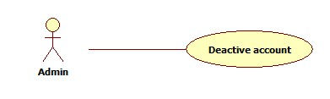

|  |  |  |  |
| --- | --- | --- | --- |
| **USE CASE – AD003** | | | |
| **Use Case No.** | AD003 | **Use Case Version** | 2.0 |
| **Use Case Name** | Inactive Account | | |
| **Author** | Tran Le Tuan | | |
| **Date** | 15/01/2014 | **Priority** | Normal |
| **Actor:** Admin  **Summary:**  This user case allow admin to active an account  **Goal:**  A active account will be inactivated  **Triggers:**   * In our system, when we do not want an user to login, we inactive his/her account. The account can be activated later. * To active an account, admin must: * From the admin Home Page, click the menu item “Account Manager”. * Check the Select checkbox of the account record, select “Active” on the drop down list, and press “Process” button.   **Preconditions:**   * User must logged in the system with the role is admin * There must be at least 1 active account in database.   **Post Conditions:**   * **Success:** The selected account(s) will be inactivated. * **Fail:** No account inactivated.Transfer to error page.   **Main Success Scenario:**   |  |  |  | | --- | --- | --- | | Step | Actor Action | System Response | | 1 | Click menu item“Account Manager”. | Redirect to Account Manager Page, includes a panel with 2 tabs:   * Account List * Create Account   Current tab is Account List. This tab includes:   * Table with 5 column: * Account ID: label * Username: label * Email: label * Role: label * Action: dropdownlist, values: Inactive, Active. * Process: button | | 2 | Check the checkboxs of the account, select “Inactive” on the drop down list, and press “Process” button. | The selected account(s) will be inactivated.  [Exception 1,2] |   **Alternative Scenario:** N/A  **Exceptions:**   |  |  |  | | --- | --- | --- | | No | Actor Action | System Response | | 1 | The account has already been inactivated by another admin. | Nothing happen, the account(s) status is inactive | | 2 | Check no checkbox, press “Process” button. | Display error message:  “Please select account to inactivated.” |   **Relationships:** Manage Account  **Business Rules:**   * Admin can’t active/inactive account of themselves or other admin. | | | |

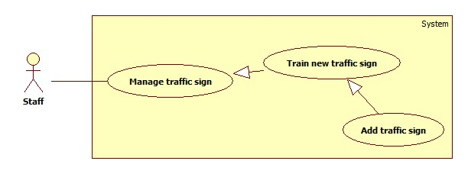

|  |  |  |  |
| --- | --- | --- | --- |
| **USE CASE** | | | |
| **Use Case No.** | AD003 | **Use Case Version** | 2.0 |
| **Use Case Name** | Add traffic sign | | |
| **Author** | Tran Le Tuan | | |
| **Date** | 15/01/2014 | **Priority** | Normal |
| **Actor:** Staff  **Summary:**  Staff use this case to add new traffic sign  **Goal:**  new traffic sign will add into database.  **Triggers:**   * We want to add a new traffic sign into database. * To add new sign, staff must: * From the staff Home Page, click the menu item “Quản lí”. * Select “Thêm biển báo” button.   **Preconditions:**   * Staff must login.   **Post Conditions:**   * **Success:** The selected sign(s) will be added. * **Fail:** No sign added. Transfer to error page.   **Main Success Scenario:**   |  |  |  | | --- | --- | --- | | Step | Actor Action | System Response | | 1 | Click menu item “Quản lí biển báo”. | Redirect to Sign Manager Page, includes a panel with 2 tabs:   * Danh sách biển báo. * Thêm biển báo.   Current tab is Account List. This tab includes:   * Table with 2 column: * Hình: label * Thông tin: label * Thêm: button * Hủy: button | | 2 | Fill information of the sign and press “Thêm” button.  [Alternative 1] | The new sign(s) will be added. System show message “Đã Thêm Biển Báo Thành Công”. |   **Alternative Scenario:**   |  |  |  | | --- | --- | --- | | No | Actor Action | System Response | | 1 | Click on “hủy” button | The form is emptied. |   **Exceptions:**   |  |  |  | | --- | --- | --- | | No | Actor Action | System Response | | 1 | Not enter enough require information. | Display error message: “Thông tin khai báo chưa đầy đủ.” | | 2 | Traffic sign name existed in database | Display error message:  “Biển báo đã tồn tại.” |   **Relationships:** Manage Account  **Business Rules:** | | | |

Export To File

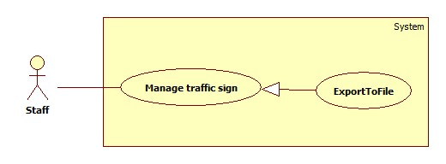

|  |  |  |  |
| --- | --- | --- | --- |
| **USE CASE – SU018** | | | |
| **Use Case No.** | SU018 | **Use Case Version** | 2.0 |
| **Use Case Name** | Export To File. | | |
| **Author** | Tran Le Tuan | | |
| **Date** | 15/01/2014 | **Priority** | Normal |
| **Actor:** Staff.  **Summary:**  Staff uses this case to export to file.  **Goal:**  Allow staff to export to file.  **Triggers:**   * Staff want to export to file. * To export file, we must :   + Staff login system  + On manage traffic sign page, click on button “Xuất tập tin” to export.  **Preconditions:**   * Staff must login.   **Post Conditions:**   * **Success**: Staff can export to file. * **Fail:** N/A.   **Main Success Scenario:**   |  |  |  | | --- | --- | --- | | Step | Actor Action | System Response | | 1 | Click on “Xuất tập tin” to request export on “quản lí” page | System will export report to file excel.  Show message “Xuất tập tin thành công”. |   **Alternative Scenario:** N/A  **Exceptions:** N/A  **Relationships:**.  **Business Rules:** | | | |
|  | | | |

Create Staff Account

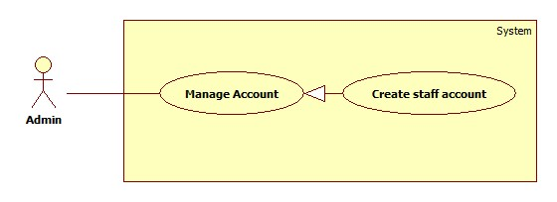

|  |  |  |  |
| --- | --- | --- | --- |
| **USE CASE – AD001** | | | |
| **Use Case No.** | AD001 | **Use Case Version** | 2.0 |
| **Use Case Name** | Create Staff Account | | |
| **Author** | Tran Le Tuan | | |
| **Date** | 15/01/2014 | **Priority** | Normal |
| **Actor:** Admin  **Summary:**  Admin use this case to create account for staff.  **Goal:**  A new account staff will be added to database  **Triggers:**   * In our system, the account of a staff will be added only by admin. * To create a new account, admin must: * From the admin Home Page, click the menu item “Quản lí tài khoản”. * In the Account Manager Page, click on the Tab “Tạo tài khoản”. * Input new account information, click “Đồng ý” to finish.   **Preconditions:**   * Admin must login system.   **Post Conditions:**   * **Success:** A new account will be created. The account will be displayed on account list. * **Fail:** No account created.Transfer to error page or still in current page.   **Main Success Scenario:**   |  |  |  | | --- | --- | --- | | Step | Actor Action | System Response | | 1 | Click menu item “Quản lí tài khoản”. | Redirect to Account Manager Page, includes a panel with 2 tabs:   * Danh sách tài khoản * Tạo tài khoản   Current tab is Account List. This tab includes:   * Table with 5 column: * Mã số: label * Tên: label * Email: label * Chức vụ: label * Tình trạng: checkbox * Action: dropdownlist, values: Khóa, Đã kích hoạt. * Đồng ý: button | | 2 | Click Tab “Tạo tài khoản”. | Display a tab panel includes:   * Tên Tài Khoản: textbox (min length, max length: 30, required). * Mật mã: textbox (password box, min length, max length: 30, required). * Chức vụ : dropdownlist, values: Nhân viên, Thành viên. * Đồng ý: button * Hủy: button | | 3 | Input new account information.  Click “Đồng ý” button.  [Alternative 1] | System will add the account to database.  Show the tab panel “Danh sách tài khoản”  [Exception 1,2,3,4] |   **Alternative Scenario:**   |  |  |  | | --- | --- | --- | | No | Actor Action | System Response | | 1 | Click on “hủy” button | The form is emptied. |   **Exceptions:**   |  |  |  | | --- | --- | --- | | No | Actor Action | System Response | | 1 | Not enter enough require information. | Display error message: “Thông tin khai báo chưa đầy đủ.” | | 2 | Username/password is not in range [6,30] | Display error message: “Tên tài khoản/Mật mã phải từ 6 đến 30 kí tự” | | 3 | Confirm password is not equal password | Display error message:  “Mật mã nhập lại không trùng khớp.” | | 4 | Username or email existed in database | Display error message:  “Tài khoản hoặc Email đã tồn tại.” |   **Relationships:** Manage Account  **Business Rules:**   * Each account is active when added to database. * The “Nhập lại mật khẩu” value must match “Mật khẩu” value. | | | |